# Software Engineering Assignments

**Diploma in Digital Marketing Assignment**

**Term-1**

## Module -1 [Software]

1. What is software? Explain Types of software.
2. Explain the SDLC Each phase process.
3. Create the DFD and use case of Flipkart.
4. Create the DFD and use case of ATM system.

## Module – 2 [Web Development]

1. Make a bank Registration Form using HTML & CSS.
2. Create Hotel Menu using List.
3. Create 3 Pages Using Inline CSS, Internal CSS & External CSS.
4. Create Page As Login With Social Media Page As below.

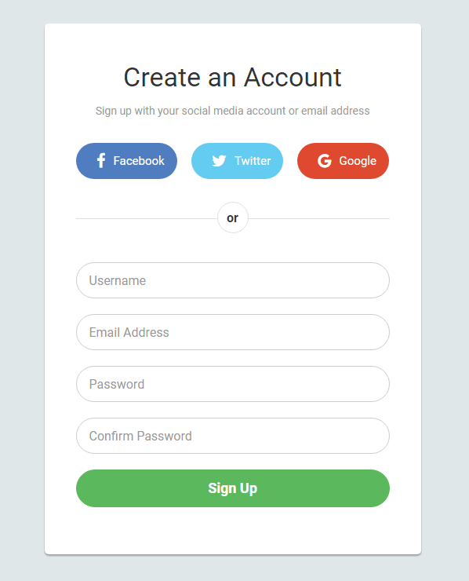

1. Use Div tag to create the below Page.

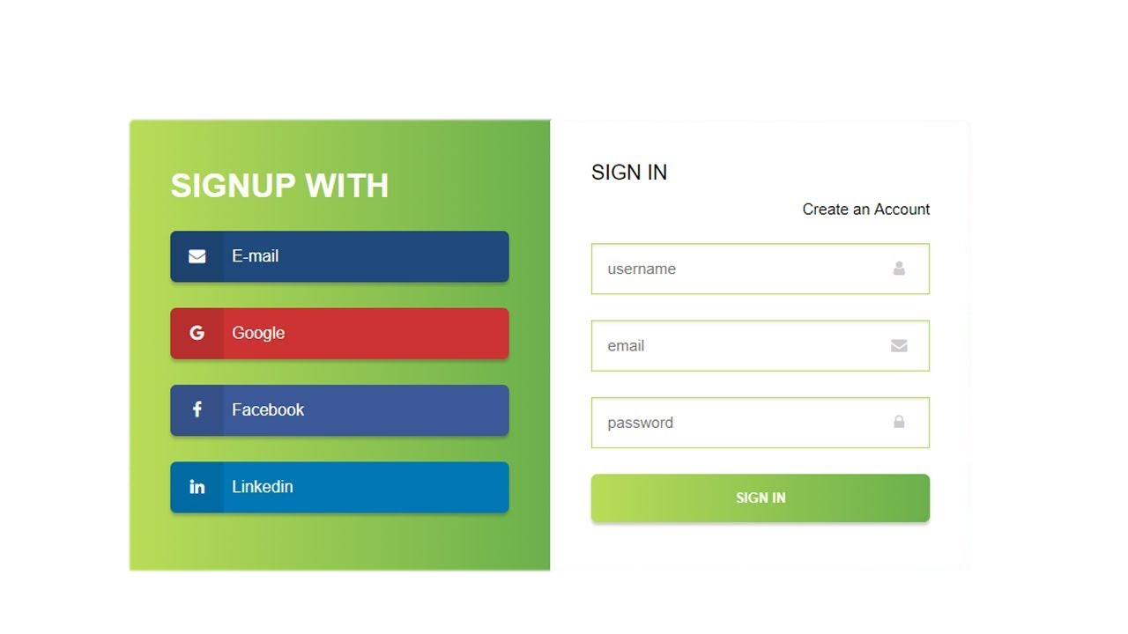

1. Create table using rowspan & colspan for Student Marksheet.
2. Create Subscribe, Join & Tweet Button using HTML & CSS with Psudo class to give Hover and Active effect.
3. Create CSS Grid Layout as Below.

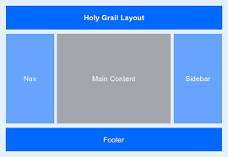

## Module-3 [C Language]

1. Display This Information using printf a. Your Name b. Your Birth date c. Your Age d. Your Address
2. Write a program to make a square and cube of number.
3. Write a program to find the simple Interest & Compound Interest.
4. Write a Program to check the given year is leap year or not.
5. Write a Program to check the given number is prime or not prime.
6. Write a program user enter the 5 subject’s mark.

You have to make a total and find the percentage. percentage > 75 you have to print “Distinction”

percentage > 60 and percentage <= 75 you have to print “First class”

percentage >50 and percentage <= 60 you have to print “Second class”

percentage > 35 and percentage <= 50 you have to print “Pass class”

Otherwise print “Fail”.

1. Write a program of to find out the Area of Triangle, Rectangle and Circle using Switch Case.

(Must Be Menu Driven).

1. Write a program you have to print the Fibonacci series up to user given number.
2. Write a program to print the number in reverse order.
3. Write a program make a summation of given number(E.g. 1523 ans :-11).
4. Pyramid Programs

|  |  |  |
| --- | --- | --- |
| *  **  ***  ****  ***** | 1  2 3  4 5 6  7 8 9 10 | * * * * *  * * * *  * * *  * *  * |

1. Write a program to find out the max number from given 10 elements of array.
2. Write a program to sort the array of 5 elements.
3. Write a Program of find the element of given position from the array.
4. Write a program to find out the Max number from given Matrix.
5. Write a program to copy string from one string to another string with user define function.
6. Write a program to find out the factorial of given number using function.
7. Write a program to print the Fibonacci series using function.
8. Write a Program of Print a number and check the number is palindrome or not using recursive Function.
9. Write a program of structure for five employee that provides the following information print and display empno, empname, address and age.
10. Write program to make a addition of two number using pointer.
11. Write a program to concatenate the two-string using pointer.
12. Write a program to sort the numbers using pointer and functions.
13. Write a program to read data from file.
14. Write a program to read and write data from the file.

## Module-4 [C++]

1. Write a C++ Program to print Message " Welcome to Tops Technologies "
2. Define a class to represent a bank account. Include the following members: Data Member: - Name of the depositor - Account Number - Type of Account - Balance amount in the account Member Functions - To assign values - To deposited an amount - To withdraw an amount after checking balance - To display name and balance.
3. Define a class to represent lecture details. Include the following members and the program should handle at least details of 5 lecturer.

Data members: Name of the lecturer Name of the subject Name of course Number of lecturers Data functions: To assign initial values to add a lecture detail to display name and lecture details.

1. Write a program of find the simple interest using constructor with dynamic initialization. Make constructor like Interest (int principal, int year, int rate) Interest (int principal, int year, float rate = 2.5)
2. Write a program to find the multiplication values and the cubic values using inline function.
3. Write a Program of Two 1D Matrix Addition using Operator Overloading
4. Write a program of to concatenate the two strings using Operator Overloading.
5. Assume a class cricketer is declared. Declare a derived class batsman from cricketer. Data member of batsman. Total runs, Average runs and best performance. Member functions input data, calculate average runs, Display data. (Single Inheritance)

9. Create a class person having members name and age. Derive a class student having member percentage. Derive another class teacher having member salary. Write necessary member function to initialize, read and write data. Write also Main function (Multiple Inheritance)

10. Assume that a bank maintains two kinds of accounts for customer, one called as saving account and other as current accounts provides Simple interest and withdraw facilities but no cheque book facility. The current account provides cheque book facility but no interest. Current account holders should maintain a minimum balance and if the balance falls below this level a service charges is imposed Create a class account that stores customer name, account number and type of account. From this derive classes curr_acc and sav_acct to make them more specific to their requirements Include necessary member functions in order to achieve the following tasks a. Accepts deposit from a customer and update balance. b. Display the balance. c. Compute and deposit interest. d. Permit withdraws and updates the balance. e. Check for the minimum balance, impose penalty, necessary and update the balance.

11.. Write a program to swap the two numbers using friend function

12. Write a program to read and write data in to file

13. Write a program of to swap the two values using templates

14. Create a example of use delete and new operator.

15. Write a program of to sort the array using templates.

## Module-5 [DBMS]

1. SQL Practices Table Name : Student and Exam

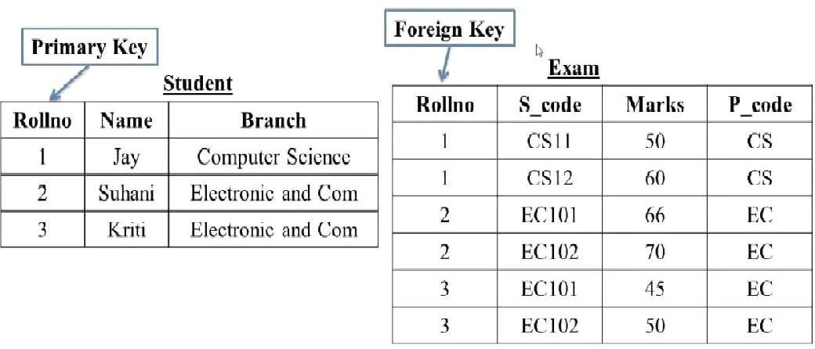

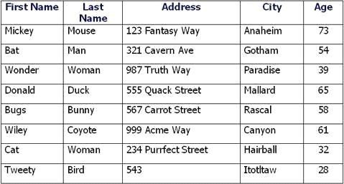

1. How to Create Table student write an SQL Query?
2. How to Create a Exam table with Foreign key on roll no write a SQL Query?
3. What is SQL Key Constraints? Write an Example of SQL Key Constraints?
4. What is SQL View Create a View of Student Table?
5. How to Create a Table user write a SQL query?
6. What is SQL and How to Create a table with Foreign Key?
7. What is trigger and how to Create a Trigger in SQL?
8. What is Difference Between DBMS and RDBMS?
9. What is Normalization?

**Table Name: Employee**

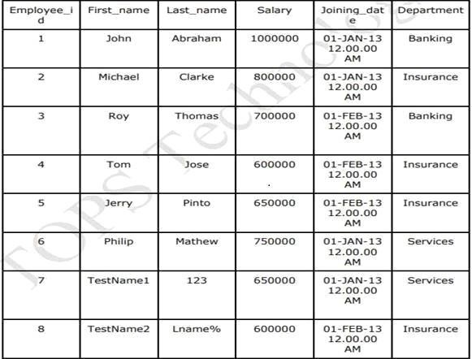

**Table Name: Incentive**

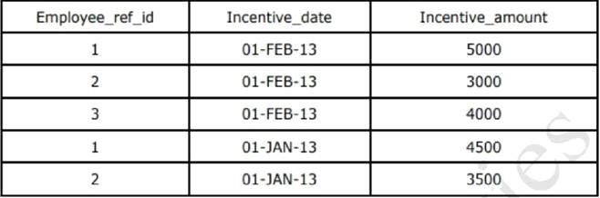

1. Get First_Name from employee table using alias name “Employee Name”.
2. Get FIRST_NAME, Joining year, Joining Month and Joining Date from employee table.
3. Get all employee details from the employee table order by First_Name Ascending and Salary descending.
4. Get employee details from employee table whose first name contains ‘o’.

Get employee details from employee table whose joining month is “january”.

1. Get department, total salary with respect to a department from employee table order by total salary descending.
2. Get department wise maximum salary from employee table order by salary ascending.
3. Select first_name, incentive amount from employee and incentives table for those employees who have incentives and incentive amount greater than 3000.
4. Select 2nd Highest salary from employee table.
5. Select first_name, incentive amount from employee and incentives table for all employees who got incentives using left join.
6. Create View OF Employee table in which store first name ,last name and salary only.
7. Create Procedure to find out department wise highest salary.
8. Create After Insert trigger on Employee table which insert records in view table.

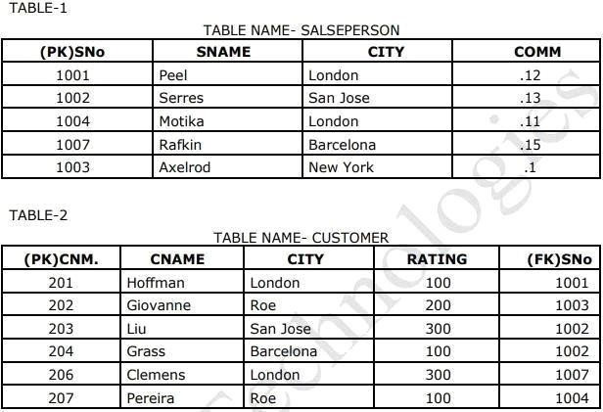

1. All orders for more than $1000.
2. Names and cities of all salespeople in London with commission above 0.10.
3. All salespeople either in Barcelona or in London.
4. All salespeople with commission between 0.10 and 0.12. (Boundary values

should be excluded).

1. All customers excluding those with rating <= 100 unless they are located in Rome.
2. All orders except those with 0 or NULL value in amt field.
3. Count the number of salespeople currently listing orders in the order table.
4. Largest order taken by each salesperson, date wise.